**Biology Revision: Preventing Diseases**

Mastery Matrix Points

|  |
| --- |
| Describe how the body prevents entry of pathogens into the body |
| Describe how the immune system tackles pathogens once they have made it into the body (phagocytosis, antibody production and antitoxin production) |
| Explain how vaccines work |
| Discuss the global use of vaccination in the prevention of disease |
| Explain the use of antibiotics and other medicines |
| Compare and contrast painkillers and antibiotics |
| Explain the benefits and drawbacks of antibiotics and limitations of antivirals |

Key Knowledge

*How do these parts of the body try to prevent pathogens entering?*

Skin -

Nose -

Trachea and bronchi -

Stomach –

Three jobs of white blood cells –

-

-

-

Definition:

Vaccination –

Phagocytosis –

Immunising –

Antibiotics –

e.g.

Painkillers –

e.g.

Antivirals –

Disadvantage of antivirals:

Understanding and Explaining

1. Describe the physical and chemical barriers preventing pathogens from entering the body.
2. Explain the roles of phagocytes and lymphocytes (types of white blood cell) in the immune system.
3. Describe and explain the shape of this graph showing the number of antibodies produced during a first and second chickenpox infection.

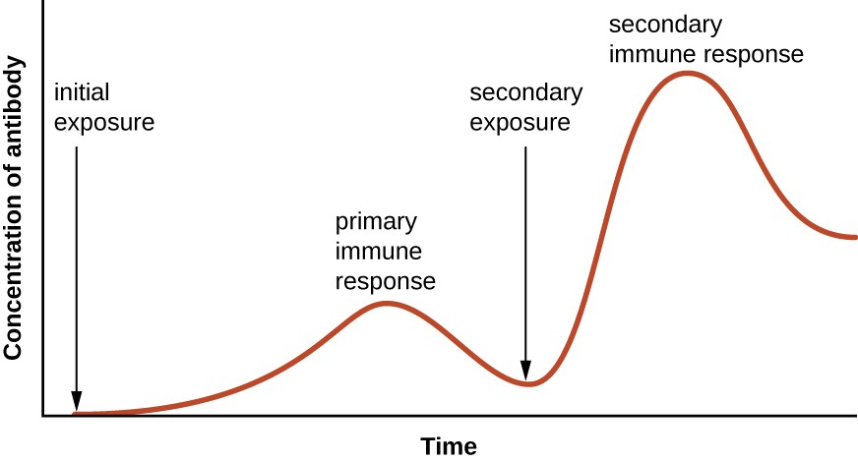

1. Explain how the measles vaccine helps to prevent a person becoming ill from the measles pathogen.
2. The flu vaccine is often given out in the UK to vulnerable groups, rather than the whole population. Discuss why the government has chosen to immunise only select groups of people, such as 65+ years old and pregnant women.
3. A student has influenza cause by a virus. Discuss which of the medicines, painkillers, antibiotics or antivirals, would be suitable to give them. Explain why.